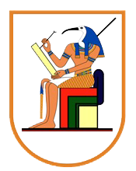

Cairo University Computer Engineering Department

Faculty of Engineering Third year

**computer graphics**

**Crazy Taxi Game**

**Team#14 Members**

|  |  |  |
| --- | --- | --- |
| **Name** | **Section** | **B.N.** |
| Gheiath Omar Saleh | 2 | 7 |
| Mohamed Akram | 2 | 11 |
| Mostafa Mohamed Elgendy | 2 | 27 |
| Youssef Atef Tawfik | 2 | 42 |

**June 2022**

Distribution:

menu



Car

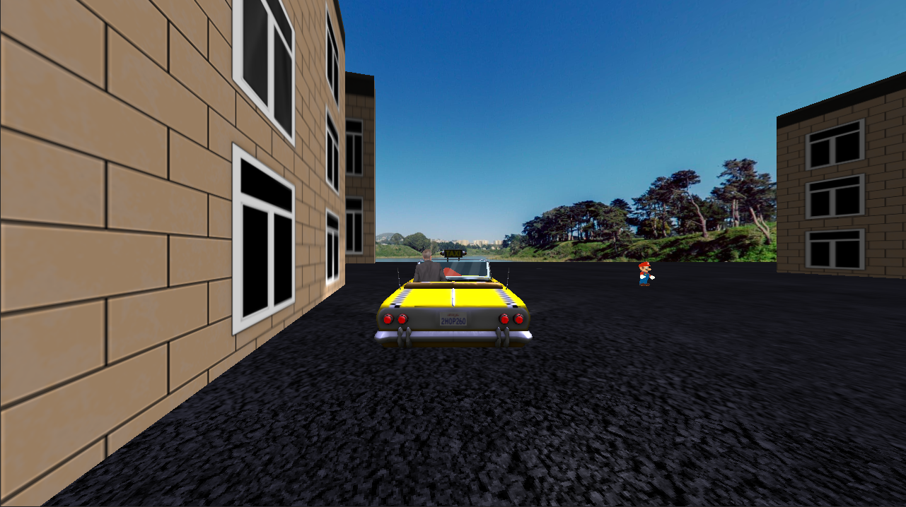

Passenger-1

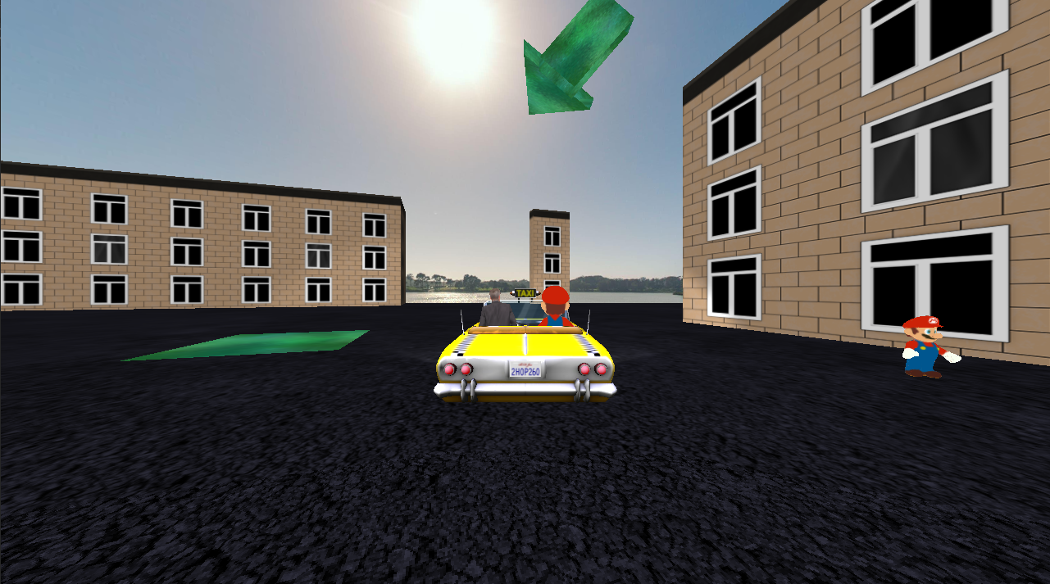

Passenger-2

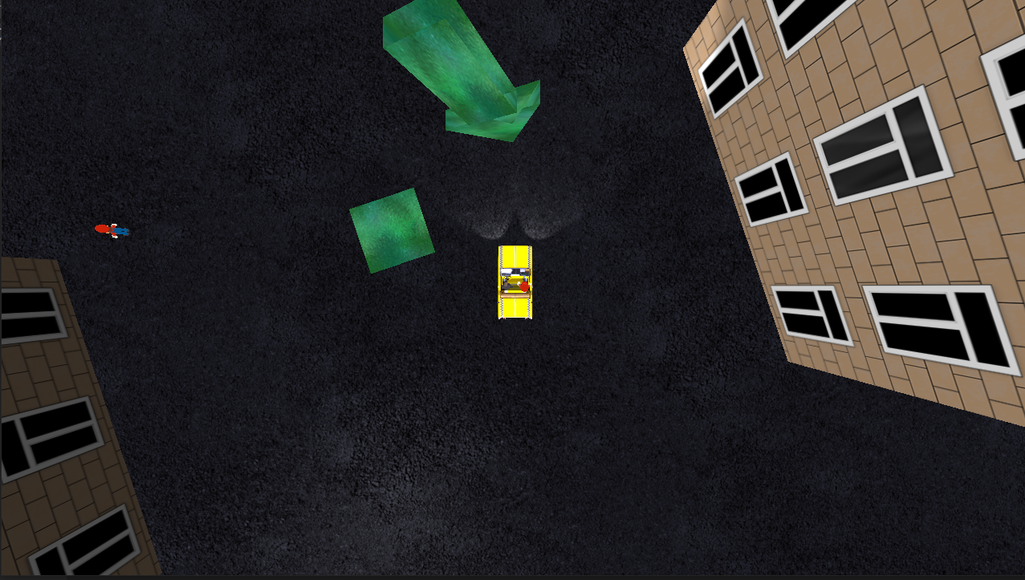

Passenger-3

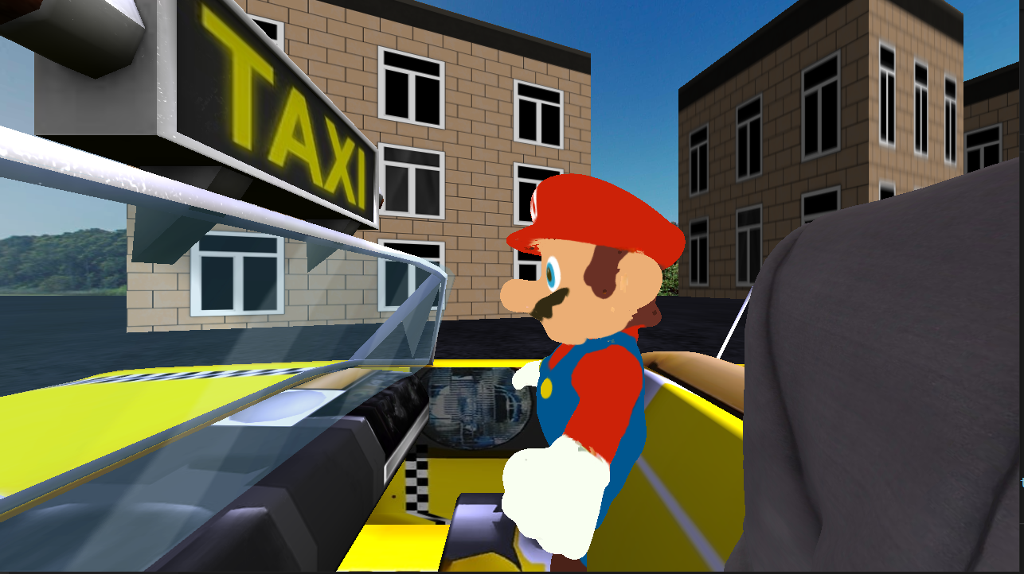

Collision

